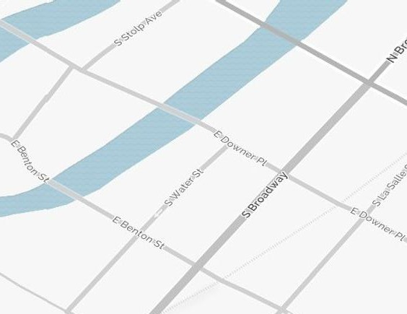
Galena is a 1 way St heading East

City Parking
Galena Blvd

Downer St is a 2 way St.

Water St. Mall. Vendors and Mundy Park stage

Mundy Stage

Load in at Downer St & Water St. Enter Downer from the East. (Broadway)

Route 25
Main Stage

Benton is a 2 way Street

Parking for vendors on South side of Benton.
Watch one way Streets in Aurora. Benton & Downer St are 2 way and you can access from either East from Rt 25 or West from River St.

