ART & CRAFT EXHIBITORS’ REGISTRATION FORM
FOR THE CITY OF LIGHTS UKULELE FESTIVAL (COLUF)
August 25th 2019. 11 am to 6 pm
Name Address City State Zip Phone Email Website
- Give a brief description of your art or craft. (COLUF) reserves the right to decline applications for media inappropriate to the event)

- Will you demonstrate your art? Yes No Please describe

- Exhibit space needs and costs.
Commercial booth space, outside $50.00 10 x 10 Tent area
Organization booth space outside $37.50 10 x 10 Tent area
Business card program ad $25.00 See rate sheet for larger ads Total sum of above fees
- If you are placing an ad, include camera-ready ad copy. See the rate chart on the last page for sizes and cost. Return this form with ad copy by August 1st. Call if the deadline is a problem.
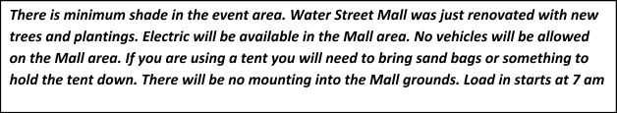
- Registrations should be received by August 1st. Ad copy must be received by August 1st. Enclose a check payable to: City of Lights Ukulele Society.
Mail to:
City of Lights Ukulele Society
Mark Strausberger
1338 S Broadway Rd Montgomery, IL 60538
(630-844-4558
mark@cityoflightsukulelefestival.com
Please call 630-844-4558 with any questions

