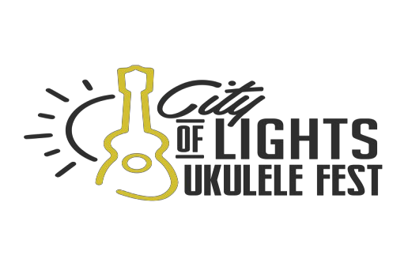

Some Festival and Advertising Information
The City of Lights Ukulele Society is celebrating its second year for the City of Lights Ukulele Festival on August 24th and 25th​, 2019​,​ in Aurora, Illinois, in Chicago's western suburbs​. The City of Lights Ukulele Festival, in its second year is generating excitement all across the country and in our local community. Every day we are getting new volunteers, sponsors, vendors and like-minded participants to join in this family friendly, all around fun festival. Our plans are to become the largest ukulele festival in the Midwest within the next few years. There will be mini-concerts, sing and play alongs, topical music workshops or hands-on educational workshops on a variety of related subjects. We will also' feature a folk arts area where artisans and instrument-makers demonstrate and sell their work, and a children's area with projects and entertainment. Food is available at the Festival. We encourage you to bring water with you, and your own chairs. No large coolers. ​Alcohol will not be allowed to be brought in from outside.
There will be no beer vendor on site. But there will be local venues serving alcohol, also you can visit one of the many fine restaurants that are an easy walk from the Festival. The ​Metra railway station is only a few blocks from Water Street Mall, and if you don't take the train there is hundreds of parking spots available in the downtown area. The downtown Aurora area is becoming a leader in the music and arts scene, With RiverEdge Park, The Paramount Arts Center and dozens of restaurants’ and arts and entertainment, the downtown Aurora area is becoming the go-to place in the music and arts scene, please contact us at 630-844-4558, and we would be happy to answer any questions you may. We are a 501C3 non-profit. Support donations over the basic ad rate are tax deductible and all Supporting, Contributing and Sponsoring advertisers will receive special recognition in the “Friends of the Festival" ​ section, inside the front cover of the book. Sponsoring ​ and Contributing ​ Advertisers will also be recognized on a Festival banner near the main stage. We would also be happy to discuss in-kind donations of products or services.
We prefer that you transfer your ads to us electronically, and if you need help with that process please contact us for instructions. TIF or PDF files typically produce the best results but most other options are also possible. Please contact us before sending files to verify options. ​ Send your ads or direct your questions to any of the following addresses:
City of Lights Ukulele Society
1338 S Broadway Rd
Montgomery, IL 60538

Mark Strausberger
630-844-4558
www.cityoflightsukulelefestival.com

6-24-19

